Advanced Institute of Education, Palwal
Details of Teaching Faculty Session 2023-24
Sr. No | Name | Designation | Qualification | Pay Scale | D.O.J | Photograph
1 | Prof. Laxmi Sharma | Principal  Professor(M.Ed) | M.Sc. (Zoology), M.Ed. (Gold Medalist)  NET-JRF (Education),  Ph.D (Education) | 37400-67000+AGP10000 | 1/09/2007 | 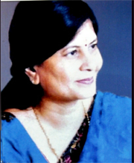
2 | Ms. Geeta Harsana | Assistant Professor | M.Sc (Botany), M.Ed., NET (Education) | 15600-6000AGP-39100 | 15/9/2009
3 | Ms. Binti Dua | Assosiate Professor | M.Sc. (Chemistry), M.Ed., NET(Education)  Ph.D (Pursuing)  (DEI, Agra) | 15600-6000AGP-39100 | 13/9/2012
4 | Ms. Komal Sharma | Assistant Professor | M.A (English, Psychology), M.Ed., NET (Education)  Ph.D (Pursuing) (JMIU, Delhi) | 15600-6000AGP-39100 | 2/11/2011
5 | Mr. Manoj Kumar | Assistant Professor | M.A (English), M.Ed., NET (Education) | 15600-6000AGP-39100 | 1/09/2012
6 | Ms. Babita | Assistant Professor | M.Sc. (Math), M.Ed. | 15600-6000AGP-39100 | 15.11.2016 | 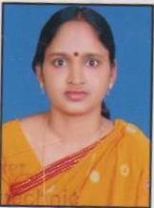
7 | Mr. Surendra Pratap Singh | Assistant Professor | M.A (Pol Science), History, M.Ed.,  NET(Education) | 15600-6000AGP-39100 | 02.08.2017 | 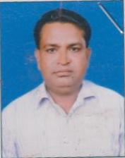
8 | Ms. Madhu Hans | Assistant Professor | M.A. English, M.Ed., M.Phil. (Edu), NET (Edu) | 15600-6000AGP-39100 | 1.10.2018 | 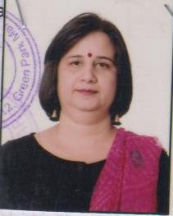
9 | Ms. Rekha Gupta | Assistant Professor | M.Sc. Zoology, M.A. Psycho, M.Ed. NET (Education) | 15600-6000AGP-39100 | 12.11.2018 | 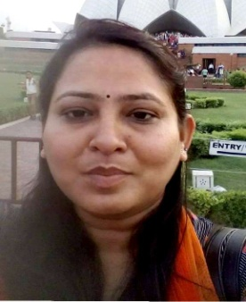
10 | Dr. Kritika Mishra | Assistant Professor | M.Sc., M.Ed. NET (Education), Ph.D. (Education) | 15600-6000AGP-39100 | 1/2/2018 | 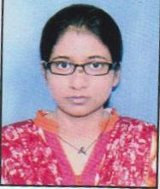
11 | MS. ANURADHA | ASSISTANT PROFESSOR | M.Com. Commerce, M.Ed | 15600-6000AGP-39100 | 01-01-2016
12 | MR. MANVEER SINGH | ASSISTANT PROFESSOR | M.A. Sanskrit, M.Ed, NET, M.Phil | 15600-6000AGP-39100 | 01-10-2021
13 | Mrs. Arvinder Kaur | Assistant Professor | M.A. English, M.Ed. | 15600-6000AGP-39100 | 02-07-2012
14 | Mrs. Pomilla Chopra | Assistant Professor | M.A. Sociology, M.Ed . | 15600-6000AGP-39100 | 02-07-2012
15 | Ms. Ruchika Sharma | Assistant Professor | M.Sc. Math, M.Ed. | 15600-6000AGP-39100 | 07-10-2016
16 | Ms. Saraswati | Assistant Professor | M.A. Hindi, M.Ed. | 15600-6000AGP-39100 | 13-11-2018
17 | Ms. Koshika | Assistant Professor | M.A. Economics, M.Ed. | 15600-6000AGP-39100 | 1.08.2019 | 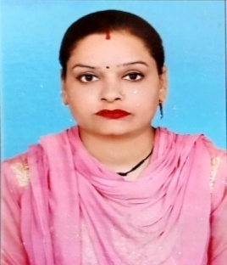
18 | Ms. Niti | Assistant Professor | M.A. Hindi, Sanskrit, M.Ed. | 15600-6000AGP-39100 | 1.08.2019 | 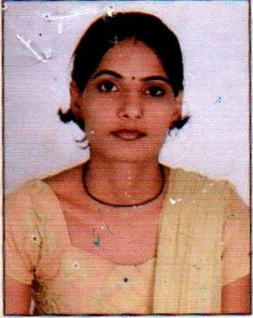
19 | Ms. Princy Mangla | Assistant Professor | M.A. English, M.Ed. | 15600-6000AGP-39100 | 1.08.19 | 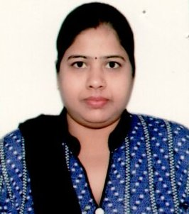
20 | Ms. Sushma Rani | Assistant Professor | M.A. Political Science, M.Ed. | 15600-6000AGP-39100 | 16-01-2019
21 | Ms. Suman Bala | Assistant Professor | M.A. Political Science, M.Ed. | 15600-6000AGP-39100 | 16-01-2019
22 | Mr. Gaurav Kumar Sharma | Assistant Professor | M.Sc. Math, M.Ed. | 15600-6000AGP-39100 | 07-10-2016
23 | Mrs. Chandervati | Assistant Professor | M.A. (English), M.Ed. | 15600-6000AGP-39100 | 1/5/2023
24 | Ms. Poonam | Assistant Professor | M.A (Hindi), M.Ed | 15600-6000AGP-39100 | 1/2/2023 | 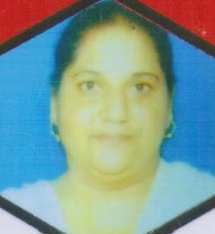
25 | Mrs. Dharamwati | Assistant Professor | M.A. (Hindi) M.Ed. | 15600-6000AGP-39100 | 1/5/2023 | 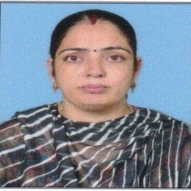
26 | Mrs. Ritu Chaudhary | Assistant Professor | M.A. (Hindi) M.Ed. | 15600-6000AGP-39100 | 1/5/2023 | 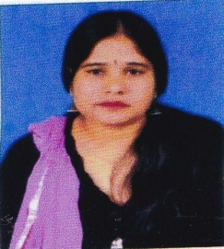
27 | Preeti Bala | Assistant Professor | M.A. (Hindi) M.Ed. | 15600-6000AGP-39100 | 18.09.2018 | 